MINI LINUX SHELL WITH
BACKGROUND JOB MANAGEMENT
OPERATING SYSTEMS HACKATHON — PROJECT REPORT
Team Members
M. Lalitha (2520080063)
Himasree (2520090181)
P. Sravya (2520090059)
Project Guide: Dr. ALekhya
Technology: C, POSIX system calls, GCC, WSL Ubuntu
Date: 17 October 2026

Abstract
Mini Linux Shell with Background Job Management is an educational command-line shell implemented in C and run in Ubuntu through Windows Subsystem for Linux (WSL). It accepts ordinary commands, supports background execution with the ampersand (&), and maintains a job table containing job numbers, process IDs, process states, and elapsed time. The shell includes built-in commands for listing jobs, stopping and resuming jobs, terminating jobs, viewing command history, changing directories, and exiting. The supplied terminal evidence demonstrates compilation, background job execution, job completion reporting, stop/resume/termination of a test process, elapsed-time display, and command history. The project illustrates operating-system concepts including process creation, program replacement, process waiting, and signal delivery.

1. Introduction
A shell is a command interpreter that provides a user interface to an operating system. It reads commands, launches programs, and helps users manage running processes. This project builds a small shell to demonstrate the basic mechanisms behind command execution and background process management rather than reproducing every feature of a production shell such as Bash.

2. Problem Statement
Long-running commands can block a terminal when run in the foreground. Users also need a way to identify background processes, inspect their state, and control them without manually searching for process IDs. The project addresses these needs with a simple prompt, background execution, a job list, and job-control commands.

3. Objectives
- Execute external Linux commands from a custom shell prompt.
- Run commands in the background when the command ends with '&'.
- Track jobs using a job number, PID, command text, state, and elapsed time.
- Display running, stopped, and finished job states.
- Send signals to stop, resume, or terminate a selected background job.
- Provide basic command history and a built-in cd command.
- Demonstrate process-management concepts using C and POSIX APIs.

4. Scope
The shell is designed for a controlled educational demonstration in WSL Ubuntu. It supports simple space-separated command arguments and selected built-in commands. It is not a full Bash replacement. Features such as pipes, input/output redirection, shell quoting, wildcard expansion, command substitution, scripting, and full terminal foreground/background job control are outside the current implementation.

5. Tools and Technologies
- Programming language: C.
- Operating environment: Ubuntu running under Windows Subsystem for Linux (WSL).
- Compiler: GCC.
- Editor: Nano or another text editor.
- Main headers: stdio.h, stdlib.h, string.h, unistd.h, sys/wait.h, signal.h, time.h, errno.h.

6. System Design
The shell repeatedly prints the mini-shell$ prompt and reads a line with fgets(). It checks for built-in commands such as jobs, history, cd, stop, resume, kill, and exit. For an external command, it tokenizes the input and creates a child process with fork(). The child calls execvp() to run the selected program. For a foreground command, the parent waits for completion. For a command ending in '&', the parent records the job and returns to the prompt. The job-listing and update logic checks process status and reports the current state.
- Display the shell prompt and read a command.
- Recognize built-in commands and detect a trailing '&'.
- Split a normal command into an argument list.
- Call fork() to create a child process.
- In the child, call execvp() to execute the requested program.
- In the parent, wait for foreground jobs or record background jobs.
- Refresh and display job states when the jobs command is entered.

7. Important System Calls and Functions
Function | Purpose
fork() | Creates a child process.
execvp() | Replaces the child process image with the requested command and searches PATH.
waitpid() | Waits for a child or checks its state; WNOHANG supports non-blocking checks.
kill() | Sends a signal to a process; this project uses SIGTERM, SIGSTOP, and SIGCONT.
chdir() | Changes the working directory of the shell process.
fgets() | Reads a command line from standard input.
strtok() | Splits simple command input into tokens.
time() / difftime() | Records timestamps and calculates elapsed duration.

8. Implemented Features
- External command execution: Runs commands such as pwd, ls, date, and sleep through child processes.
- Background execution: A trailing & starts a command without blocking the prompt.
- Job listing: jobs reports job number, PID, status, elapsed seconds, and command.
- Stop and resume: stop <job_number> sends SIGSTOP; resume <job_number> sends SIGCONT.
- Termination: kill <job_number> sends SIGTERM to a tracked background process.
- Command history: history lists commands entered in the current shell session.
- Directory change: cd changes the shell's current working directory.
- Exit handling: exit ends the shell and attempts to clean up managed child processes.

9. Compilation and Execution
Open WSL Ubuntu, change to the folder containing mini_shell.c, then compile and run:
cd ~/OSLab
gcc -Wall -Wextra -std=c11 mini_shell.c -o mini_shell
./mini_shell
A successful compilation with no output indicates that GCC completed without reporting warnings or errors.

10. Testing and Results
The following results are based on the terminal screenshots supplied during project development. Results describe the observed tests only; any feature not shown in the supplied evidence should be tested again before final submission.
Test case | Expected result | Observed result
Compile with GCC | Executable is produced without compiler errors. | Screenshot shows the GCC command completing and the shell launching.
Background completion | Short sleep job eventually reports Finished. | Observed: sleep 2 & was reported Finished.
Job status and timing | jobs shows PID, state, and elapsed time. | Observed: Running and Finished states with elapsed seconds.
Stop a job | Active job changes to Stopped. | Observed: job 5 was reported Stopped.
Resume a job | Stopped job changes to Running. | Observed: job 5 was reported Running after resume.
Terminate a job | Job eventually reports Finished. | Observed: job 5 was reported Finished after kill.
Command history | history prints numbered commands. | Observed: numbered command history displayed.
Directory change | cd changes the current directory. | Not shown in the supplied screenshots; test before claiming as verified.
Invalid command handling | Unknown command produces an error without crashing. | An invalid sleep argument produced an error; full invalid-command tests should be repeated.

11. Screenshot Evidence
The screenshots below are the actual terminal images supplied for this report.
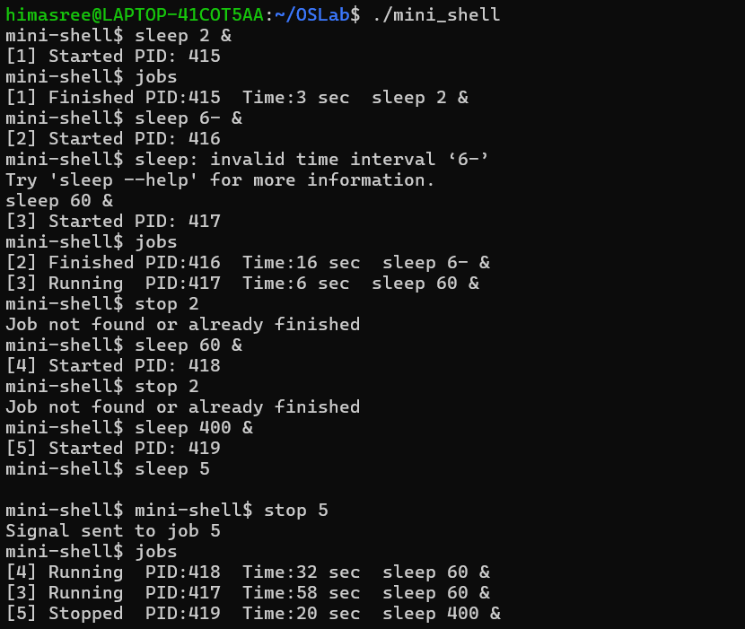
Figure 1. Background process completes and jobs reports Finished.
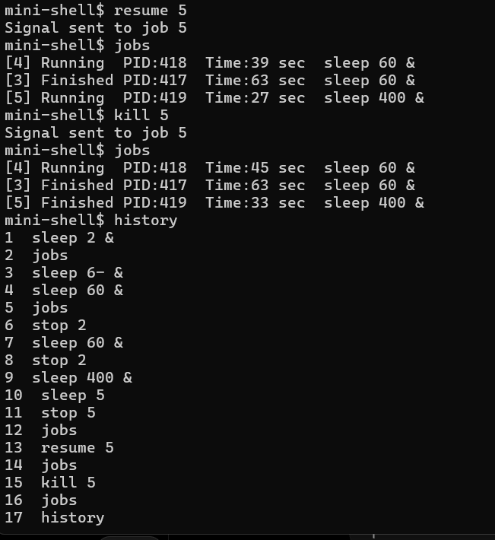
Figure 2. Command history lists commands entered in the session.
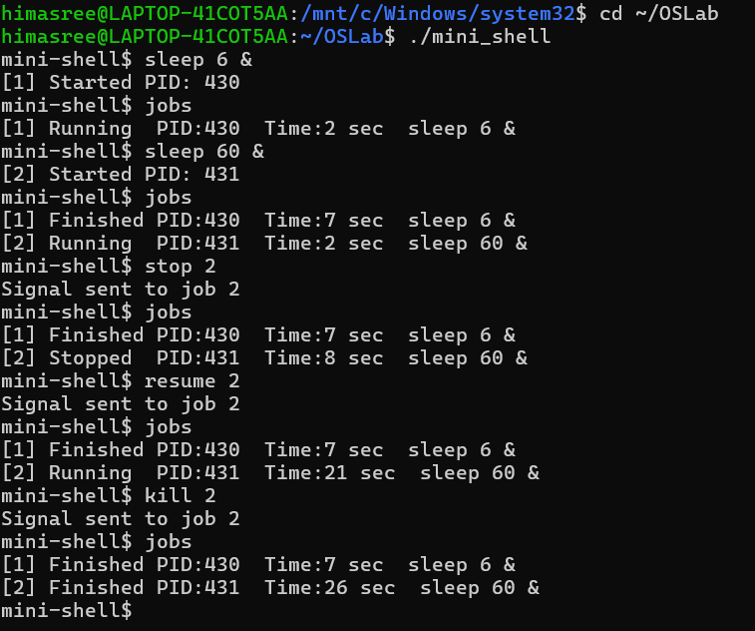
Figure 3. Job control test: job 2 is stopped, resumed, and terminated.
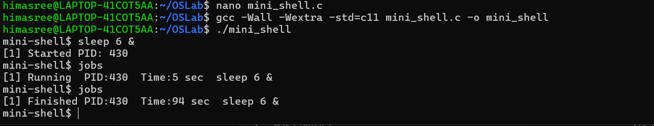
Figure 4. Compilation and background job status output.

12. Live Demonstration Plan
- Show the source file and compile it with GCC.
- Run pwd and ls to demonstrate external command execution.
- Run sleep 3 & and then jobs to show background execution and completion.
- Run sleep 60 &, then use the displayed job number with stop, resume, and kill.
- Run history and cd to demonstrate built-in commands.
- Explain the role of fork(), execvp(), waitpid(), and signals.

13. Responsible Use and Safety
Demonstrations should use harmless test programs such as sleep. The shell should only be used to manage processes started for the test, and signals should not be sent to unrelated system processes. The implementation should be evaluated in a controlled WSL environment.

14. Limitations
- No pipes or input/output redirection.
- No support for quoted arguments, wildcard expansion, or command substitution.
- No complete terminal job control or fg/bg commands.
- Fixed limits for command-line length, history, and job table.
- Job-state behavior should be retested under rapid process completion and repeated signals.

15. Future Enhancements
- Add pipes and input/output redirection.
- Improve asynchronous child-state handling and process-group management.
- Add persistent command history.
- Support quoted arguments and more robust command parsing.
- Add fg/bg commands and terminal signal handling.

16. Conclusion
The Mini Linux Shell with Background Job Management demonstrates the core concepts of command execution and process control in a compact C program. The supplied evidence confirms background job execution, status listing, completion reporting, stop/resume/termination of a test job, elapsed-time display, and command history. The project is suitable as an educational prototype, with the stated limitations and remaining unverified behaviors disclosed during evaluation.

